

Project Estimate

Wedding Booking Service System

Version 1.0

Lead Id:

**CONFIDENTIAL**

Feb 14, 2018

This document outlines the general scope of your project based

on our understanding of the requirements provided

and discussions to date.



**DISCLAIMER**

This document is submitted with the explicit understanding that the contents are confidential

and would not be divulged to any third party without prior written consent from Dotsquares Ltd.

Services are supplied according to our terms and conditions

<http://www.dotsquares.com/terms>

Contents

Our Recent Achievements 2

Version Control Table 2

Purpose of Document 3

Objective 3

Deliverables 3

System Features 4

Users 4

Note 11

Technology 11

Estimate Breakdown 12

Additional Features 12

Optional Extras 13

Our Other Services 13

# Our Recent Achievements

One of our project – **Fujitsu Mosaic Desktop application** has got a place in Guinness book of world records



**Follow the Link here** - **http://blog.global.fujitsu.com/weve-co-created-a-fujitsu-world-record/**

# Version Control Table

|  |  |  |  |
| --- | --- | --- | --- |
| **Date** | **Version** | **Description** | **Author** |
| **14 Feb 2018** | **V1.0** | **Initial Project Scope** | **Dotsquares** |

# Purpose of Document

This document outlines the general scope of your project based on the requirement provided and discussions to date. The main objective at this stage is to ensure that all parties agree upon the general scope, budget and schedule of the project prior to commencing work on subsequent stages (which can include in-depth planning if needed).

Clients are urged to ensure that all the details contained within this document are clear and fully meet their requirements before further work commences. Timescales mentioned only cover the scope listed, if this changes, costs and timings will change accordingly.

Once you are happy contact us and we will progress into the next stages. This may include further detailing requirements and functionality or it may go straight into design. This will depend on the nature of the project.

# Objective

The objective of the project is to create Wedding Booking Service Management System where weddings, churches, Persons, payments & costs for wedding service for each church will be added and managed.

# Deliverables

|  |  |  |  |
| --- | --- | --- | --- |
|  | **Item** | **Platform/OS** | **Device** |
| 1. | Wedding Booking Service Management System | Linux/MAC/Windows | Laptop/Desktop/Mobile |

# System Features

As per shared document, we will provide following features-

**13/02/2018 Client Comment:** The system should only be available to registered users.

13/02/2018 D.S Reply: We are assuming that there will be System Admin and 2 Sub-admin (operators/Staff) who will be able to login and use the system.

We are also assuming that we are focussed mainly on functional parts (with simple UI) and Wedding management at this moment

**13/02/2018 Client Comment:** I think it should run on a MYSQL database but I am open to suggestions.

13/02/2018 D.S Reply: Ok, we will use MySQL database

We are assuming that there will be System Admin and 2 Sub-admin (operators/Staff) who will be able to login and use the system. **Sub-admins (operators/Staff) users will have ability to add new weddings as well as view/edit upcoming wedding details. System admin will have access to system and database so system admin will view/edit all upcoming weddings**

## Users

1. Login to system
2. ‘Add New wedding’ through form in system

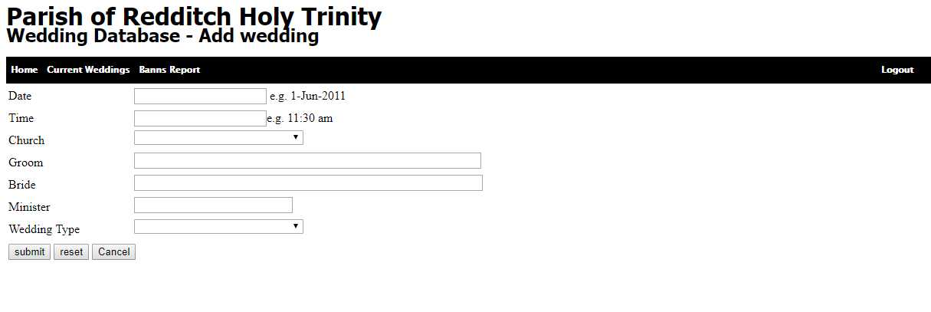

* 1. Date of Wedding – Date picker
  2. Time
  3. Church (from dropdown of church list added by system admin)
  4. Groom (text field)
  5. Bride (Text field)
  6. Minister (from dropdown of ministers list added by system admin)
  7. Wedding Type (from dropdown of Wedding types list added by system admin)
  8. Submit - Will add new wedding visible to system admin in upcoming wedding list
  9. Recent – Remove all added fields
  10. Cancel – back to screen

**13/02/2018 Client Comment:** **Wedding Management**

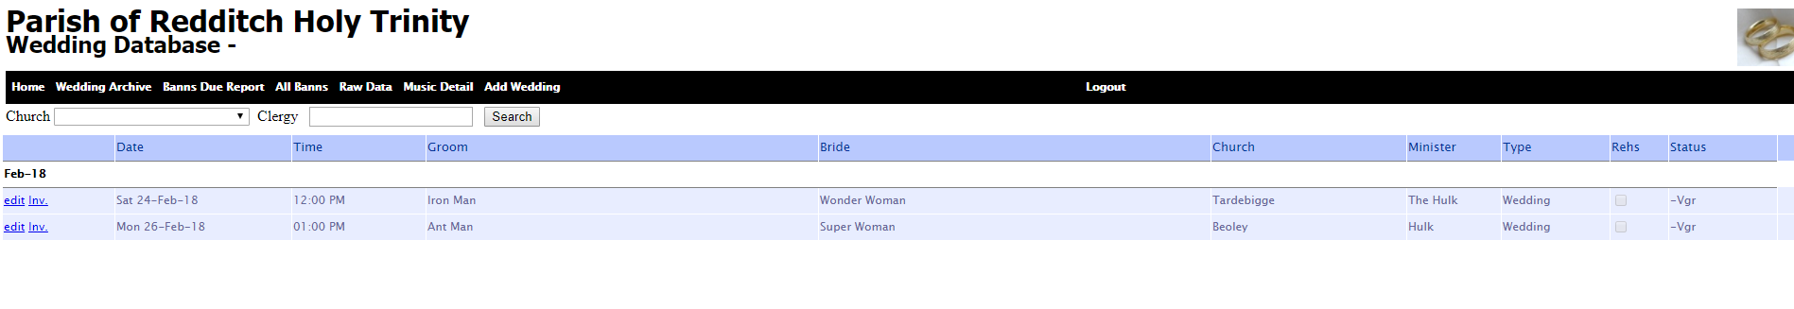

This screen will show a list of upcoming weddings and allow you to go in and edit the details... We need to be able to filter the management page on Church and/or Clergy (minister).

1. Able to view list of upcoming weddings
   1. Date of wedding
   2. Time of wedding
   3. Groom Name
   4. Bride Name
   5. Church
   6. Minister
   7. Type
   8. Edit
   9. Delete

Query: How does ‘Status’ tab will work? Please explain

1. Able to filter upcoming wedding list based on Church and ministers

**13/02/2018 Client Comment:** **Edit/Add Wedding Details**

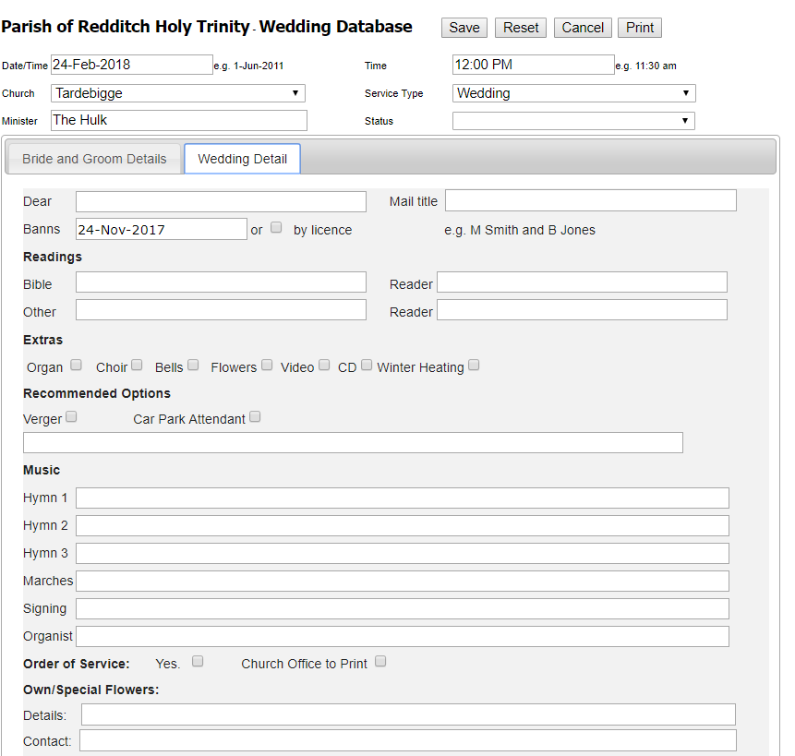

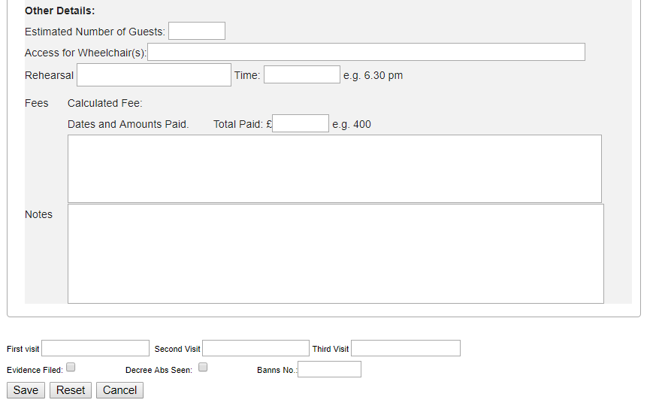

This form will allow us to add the required details in for the wedding.

Most of the information here is elf explanatory.

However for the Hymns and Readings I would like these to be held in a separate table and just added to the wedding. So that we can add as many as required.

For example with the Hymn, we would click ‘Add Hymn’ then a modal window would pop up and allow us to enter the details for that Hymn. This would create a list of hymns on the wedding details page. We can then edit and delete these as required.

1. Edit Wedding Details which consist of following fields
   1. Date
   2. Time
   3. Church
   4. Minister
   5. Status
   6. Dear – Text Field
   7. Mail Title – Text Field
   8. Banns (Date) Or by licence
   9. Bible – Text Field
   10. Reader – Text Field
   11. Extra- Selection from checkboxes
   12. Recommended Options- Selection from checkboxes
   13. Music
       1. Hymn – Will open up a modal window would pop up and allow to enter the details for that Hymn

Query: Please share the detail fields which needs to be added in Hymn Model view?

* + 1. Marches
    2. Singing
    3. Organist
  1. Order Of Service
  2. Own Special Flowers
     1. Details
     2. Contact
  3. Other Details
     1. Estimated Number of Guests – Text Field
     2. Access of wheelchairs – Text Field
     3. Rehearsal
     4. Time
     5. Fees – Calculated Fees

Each church and its extra feature have individual price which based on selection will calculate total price as-

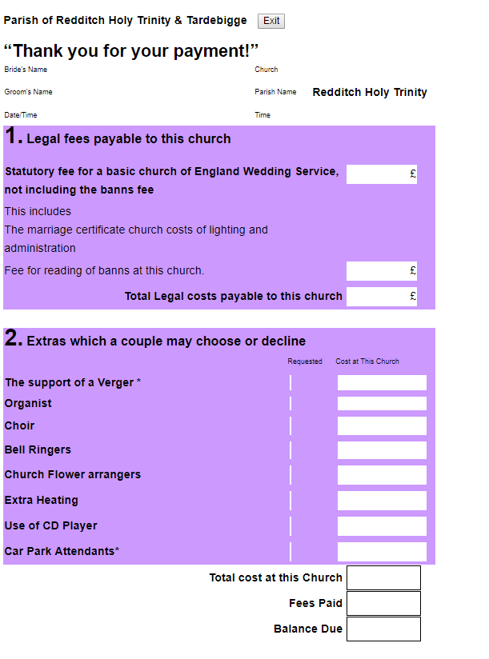

Based on selected church prices for that church will be applied. Once total fees for wedding is calculated, it will remain same even if price changed from admin panel.

* + 1. Total Paid – Text Field
    2. Notes – Text Field
    3. Visits – Selection from checkboxes
       1. First
       2. Second
       3. Third
    4. Evidence
    5. Save

As per date of wedding and start & end date of statuary fees defined from system, total price will be calculated and showcased on front

**13/02/2018 Client Comment:** **Bridge and Groom Details**

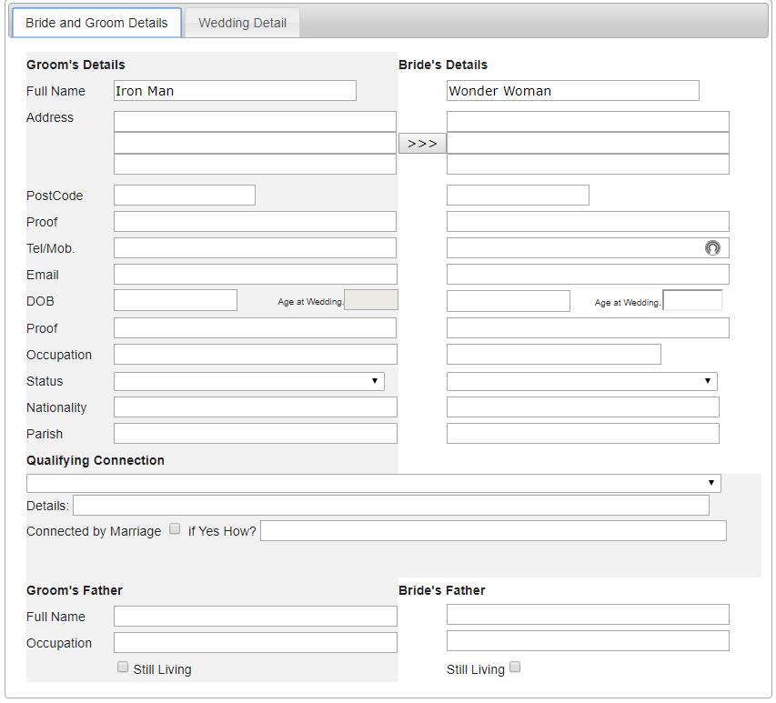

There is a separate tab for bride and groom details

When entering Bride and Groom details I would like to be able to do a lookup on Surname so if the person already exists in the database then we can find them. The chances are that the person will not exist so in this case we will have the option to ‘add new person’.

The ‘Age at Wedding’ field should be calculated so that this calculates the persons age at the time of the wedding based on their date of birth and the date of the wedding.

There is a function on the existing form to copy over address details from the Groom to the Bride on this form. This is simply a time saving device as quite often they share an address. I am not sure how/if this could work using the structure outlined above.

The way I see it working is first create the groom record / associate an existing person with this wedding as a groom. Then when clicking to create bride we can select to ‘create bride with same addresses. Then when the record is created / associated the address from the groom is used.

1. Add/Edit Bride & Groom details
   1. Full Name

Option to search person name (from person’s data added by system admin) by surname. If not added then it will create a new person and will be added in person’s list

* 1. Address (Will be able to copy address of groom in Bride just by simple click)
  2. Postcode
  3. Proof
  4. Telephone
  5. Email
  6. DOB
  7. Age – Automatically calculated as per age added
  8. Proof
  9. Occupation
  10. Status
  11. Nationality
  12. Parish
  13. Qualifying Connection
  14. Details
  15. Groom’s father

**13/02/2018 Client Comment:** The way I envisage this working is to keep the ‘person’ records at the centre of the app. essentially as a CRM. Then add the ‘Wedding’ system as a Django app. The wedding booking system would use the person records from the main app. Then as we want to add funeral and christening services we can add this on as separate apps using the same person records.

**New wedding**



This form would register a new wedding.

For the dropdown boxes of ‘church’ and ‘minister’ I would like these fields to be editable through the backend admin panel of Django. So that we can add and remove options if required in the future.

I don’t want to add the bride and groom at this point though. I want this information to be added along with all of the additional wedding details.

13/02/2018 D.S Reply: Ok,

1. Able to add/edit/delete Persons record (Directly from MySQL database)
2. Add/edit/delete Churches (Directly from MySQL database)
3. Add/edit/delete ministers (Directly from MySQL database)
4. Add/edit/delete Wedding types (Directly from MySQL database)

**13/02/2018 Client Comment** : The ‘status’ and ‘service type’ fields should be manageable through the Django admin area, so if we need to add options we can readily do this.

1. Add/edit/delete Service Types (Directly from MySQL database)
2. Able to add/edit/delete Status (Directly from MySQL database)

**13/02/2018 Client Comment**: **Extras**

The extras each have a cost associated with them.

The costs are on a church by church basis. For example, the choir at church 1 may cost £50 but at church 2 is costs £75. So depending on which Church is selected will effect which cost is assigned to the wedding.

These costs need to be manageable through the Django admin section as they are liable to change. However when an option is selected on a wedding the cost at that time must be recorded for that wedding. So if the cost changes in the future the cost of the wedding does not change.

**Payments**

Each wedding generates a certain amount of costs.

There is a statutory fee, this fee must be configurable through the Admin area. The statutory fee changes on an Annual basis and is set by the Church of England. The fee due will be based on the date of the wedding.

We need to be able to record to fee values, the current value and the upcoming value with a date at which the upcoming value takes effect.

If a wedding is booked < the date the upcoming value takes effect then the current value is assigned to the wedding. If the wedding date is > the date, then the upcoming value is assigned to the wedding.

If today’s date is > than the upcoming value date then the current value can be replaced with the upcoming value and the upcoming value left blank until it is updated again manually.

The fees for reading banns will be set on a church by church basis, and need to be manageable through the Admin panel.

I would like a form similar to the one shown above that shows all the costs for the wedding and the costs for the extras that have been selected.

It will show the balance due and also allow us to record payments against the balance.

The wedding may not be paid for in one amount, so we need to be able to record multiple payments against the wedding until the balance is paid.

This is NOT an online payment system (yet) and simply a method of tracking how much money is outstanding for any given wedding.

1. Able to manage (Set/change) (Directly from MySQL database)
   1. Price for wedding service at church individually
      1. Set statuary Fees as per date
         1. Start Date
         2. End Date
         3. Statuary Fees

As per date of wedding and start & end date of statuary fees defined from system, total price will be calculated and showcased on front

* + 1. Set price for reading banns at church individually
  1. Prices for extra services at church individually

**13/02/2018 Client Comment**: The ‘status’ and ‘Qualifying Connection’ fields should be manageable through the admin area.

1. Manage Status (Directly from MySQL database)
2. Able to manage ‘qualifying connection’ (Directly from MySQL database)

# Note

1. Any additional functionality will be estimated separately
2. Queries mentioned in red are not a part of estimation. We will provide estimation once we will get further information from your end.

# Technology

|  |  |  |
| --- | --- | --- |
|  | **Component** | **Web Application** |
| 1. | Database | MySQL |
| 2. | Language | Python/Django |

# Estimate Breakdown

|  |  |  |
| --- | --- | --- |
|  | **Deliverables** | **Time Estimate**  (In Man days) |
| 1 | Login | 0.5 |
| 2 | Form for ‘Add New wedding’ |  |
| 3 | View list of upcoming weddings added by users |  |
| 4 | Filter upcoming wedding list based on Church and ministers |  |
| 5 | ‘Add/Edit Wedding Details’ Form |  |
| 6 | ‘Add/Edit Bride & Groom’ Form |  |
| 7 | Creation Of Database tables in MySQL | 1 |
|  | * Persons record ( Add/edit/delete Directly from MySQL database **)** |
|  | * Churches ( Add/edit/delete Directly from MySQL database **)** |
|  | * Manage Pricing ( Add/edit/delete Directly from MySQL database **)** |
|  | * + statuary Fees |
|  | * + Reading Banns |
|  | * Ministers ( Add/edit/delete Directly from MySQL database **)** |
|  | * Wedding types ( Add/edit/delete Directly from MySQL database **)** |
|  | * Service Types ( Add/edit/delete Directly from MySQL database **)** |
|  | * Status ( Add/edit/delete Directly from MySQL database **)** |
|  | * Extras ( Add/edit/delete Directly from MySQL database **)** |
|  | * ‘Qualifying connection’ ( Add/edit/delete Directly from MySQL database **)** |
| 8 | Testing and uploading on Live Server |  |
|  | **Total Approximate effort (in man days)** | **days** |
|  | **Total Approximate effort (in man weeks)** | **Weeks** |

**Estimate is valid for 30 days from date of issue.**

# Additional Features

Some additional features you might like to include can be found below, unless mentioned in the estimate above they are not currently included. Please let us know if any of these features are required:

**EU Cookie Compliance:** This gives a viewer the option of not installing cookies, In-line with European privacy laws.

**PCI Compliance:** This is usually required by your payment gateway supplier as part of your ecommerce merchant account agreement.

**W3C compliance:** Why bother making your site compatible with specific browsers when you can achieve W3C compliance and make it compatible with all.

**SEO/Digital Marketing:** Development work is done in-line with best SEO practices, but this does not include SEO optimization (keyword generation, search engine submission, analytics etc.). Please see ‘additional services’ below or visit our website at: <http://digitalmarketing.dotsquares.com/>

**Hosting:** Once development is complete you will also need a web server to host the site on. We can offer very competitive hosting services (managed and unmanaged).

**Testing:** The work is tested by the developer during development, but this does not cover the same things as dedicated testing (unit testing, stress testing etc.).

**AAA Compliance:** Another W3C service, help users with visual disabilities to navigate and read your site.

**Speed Testing:** Optimise the code and server for minimal load times.

**Mail Delivery Testing:** Ensure emails always arrive by testing the mail delivery process.

# Optional Extras

|  |  |  |  |
| --- | --- | --- | --- |
|  | **Deliverables** | **Time Estimate** | **Cost/Rate** |
| 1. | W3C compliance (Cross browser testing) | - |  |
| 2. | Speed testing | - |  |
| 3. | Mail delivery testing | - |  |
| 4. | Hosting |  | - |
| 5. | Domain |  | - |
| 6. | SEO/Digital Marketing | - |  |

# Our Other Services

As well as website Development we also provide the following additional services to help our customers to get all the IT support services under one roof.

**PHP Support Packages**

Here at Dotsquares we have CMS monthly support and upgrade packages available to monitor your website, helping to making sure it’s secure from attacks and performing at the highest level for your visitors. Just like you, our objective is to provide overall customer satisfaction, which is why we have created these flexible support packages. Please check more information: <http://www.dotsquares.com/php-support/>

**Digital Marketing**

We are experts in Internet Marketing and have significant experience in the promotion of web sites. We offer our clients a range of Search Engine Optimization plans and Pay-per-Click management. We have proven successes and can help your site to get more well-targeted visitors. Why not visit our Digital Marketing site for more information: <http://digitalmarketing.dotsquares.com/>

Social media has become a platform that is easily accessible to anyone with internet access. Most of the Businesses are now available online through website and help their clients to reach them instantly. A website should be easily accessible to customers that will be possible only by marketing the website that will create Brand Awareness.

Click the below Image to play the video to learn more about our Digital Marketing services and you can get the process started by completing our kick off form: <http://www.dotsquares.com/seokickoff/>

[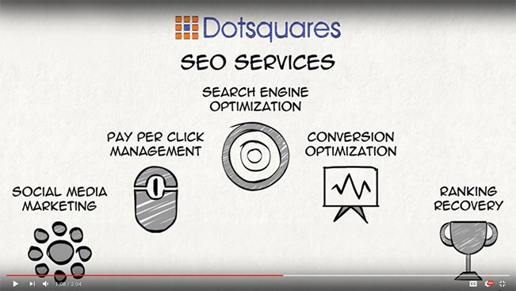](https://www.youtube.com/watch?v=UYZRF3YGEic)

**Network Support**

Network Services offered by our company are:

* Domain Registration
* Server Management
* System Backup & Restore
* Emergency Support
* Network Troubleshooting and Remote Installation